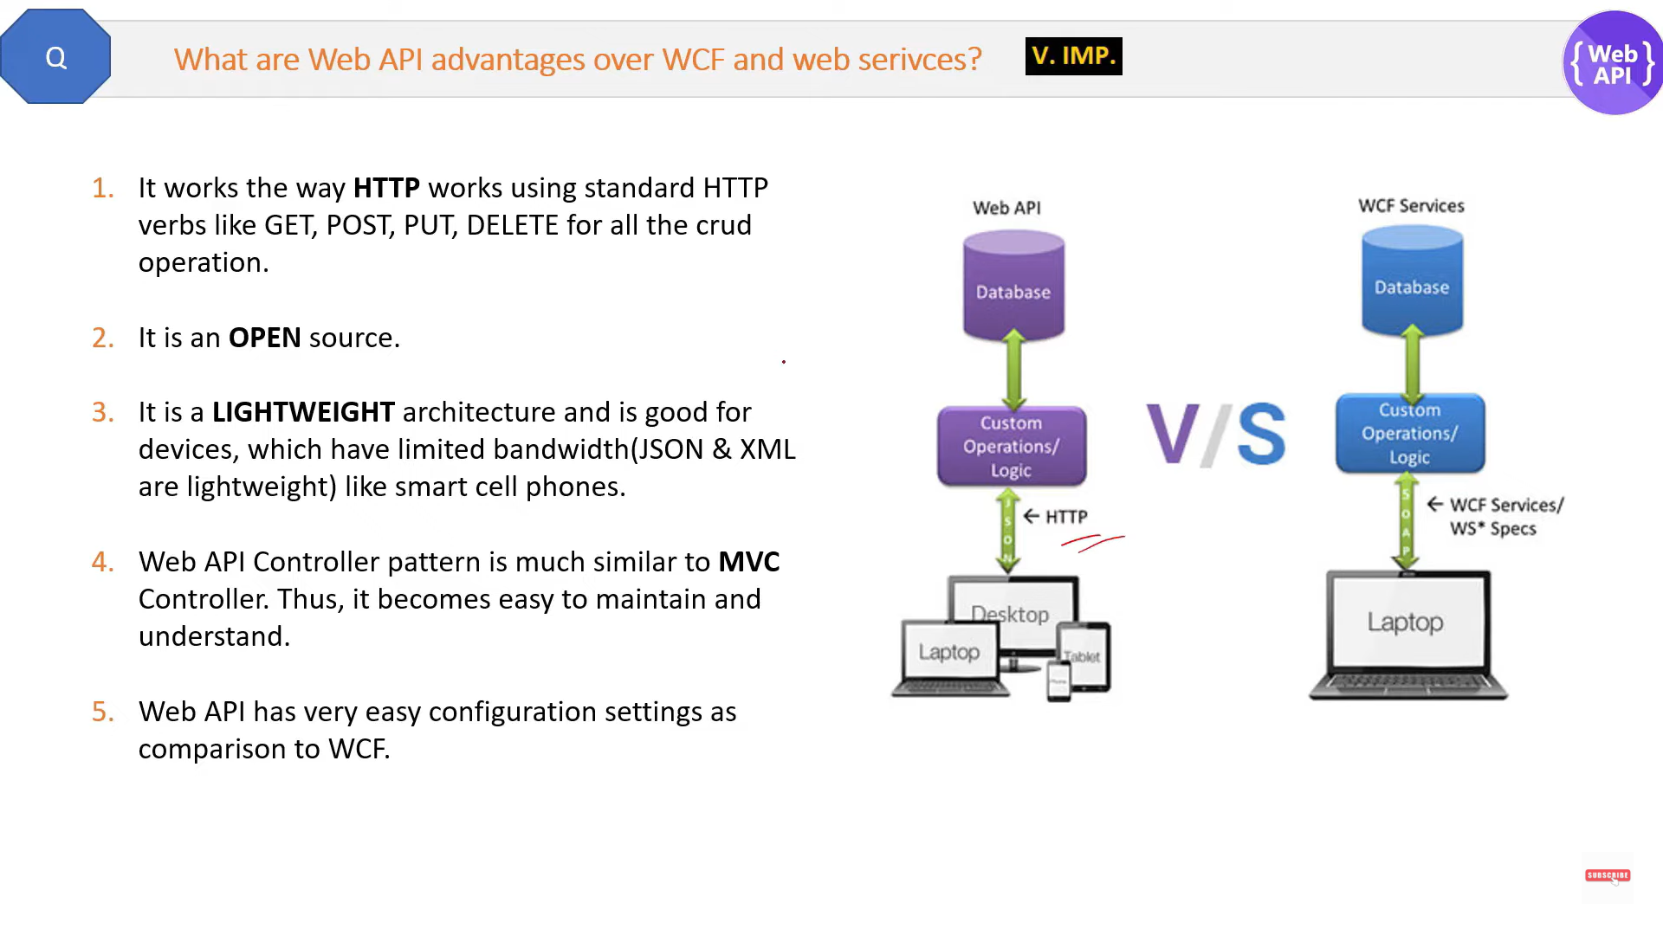

Http Verbs

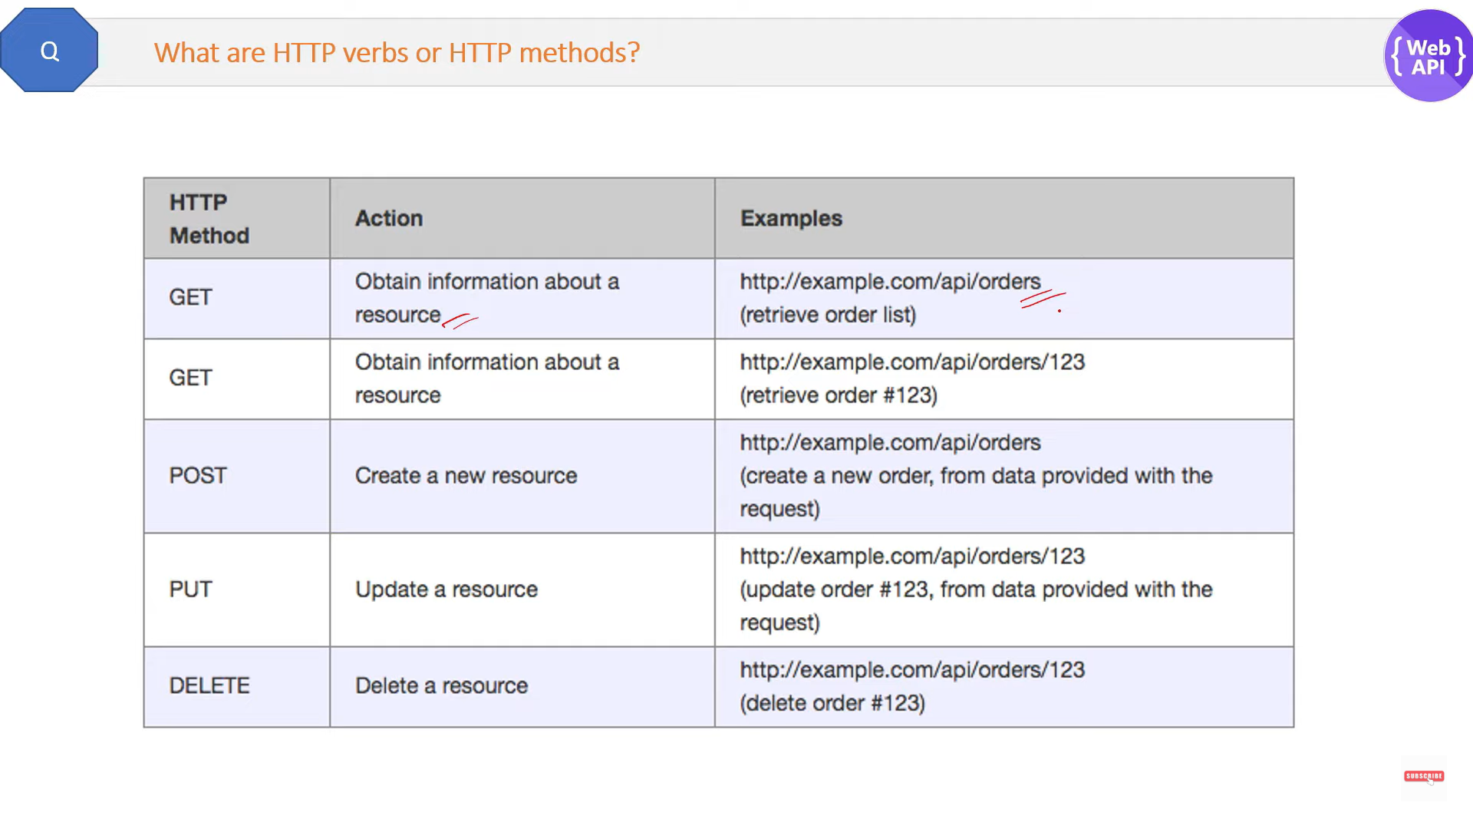

Consume Web API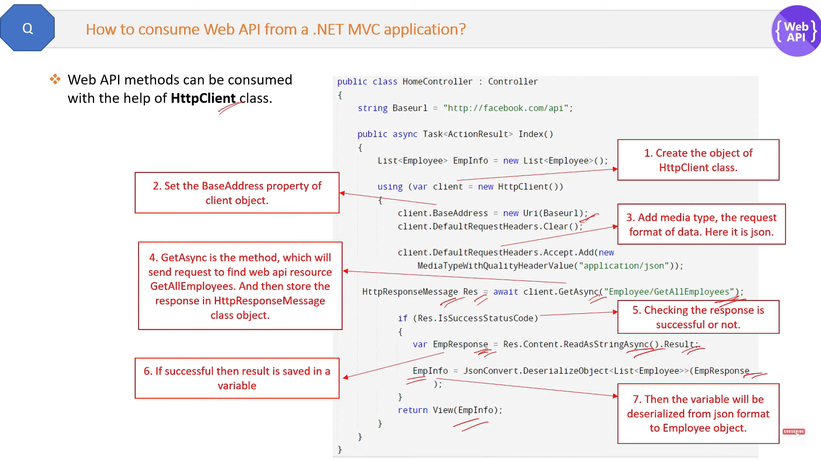

Web API controller && MVC Controller

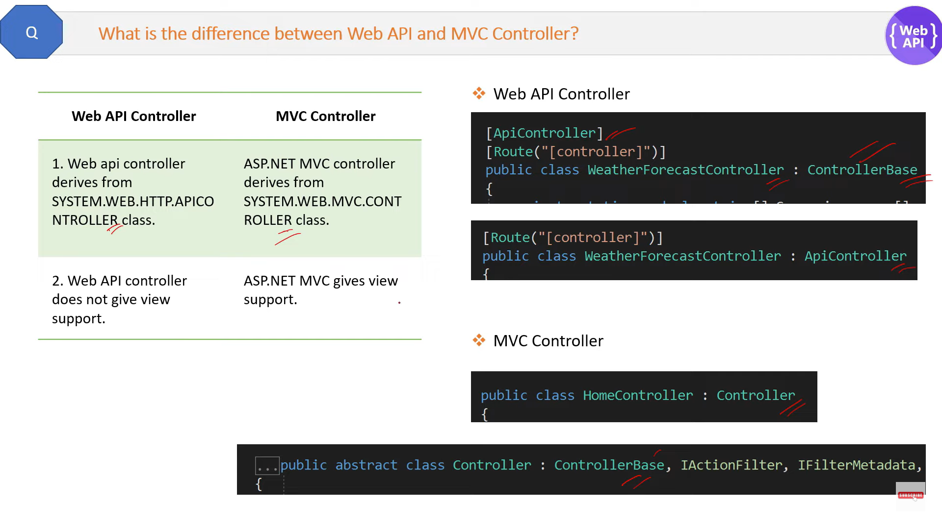

Authentication in Web API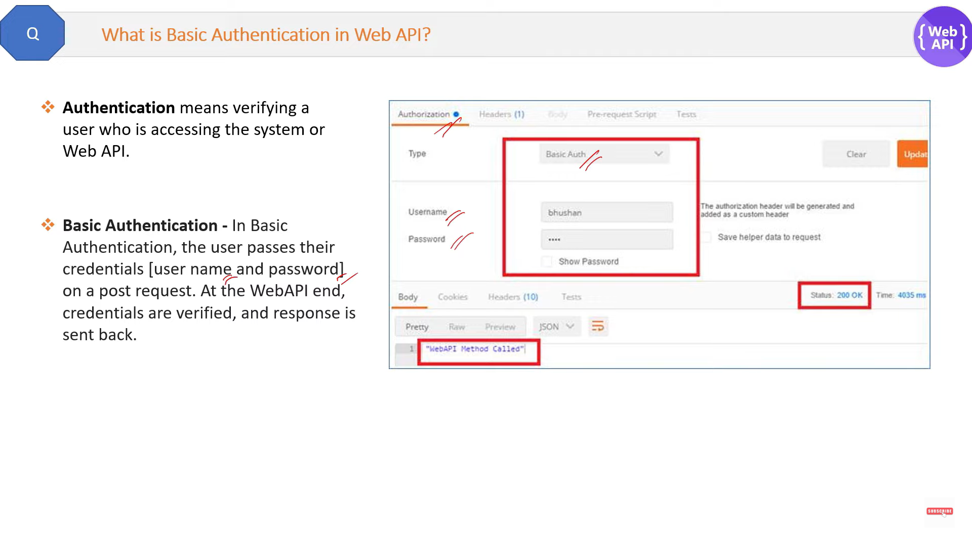

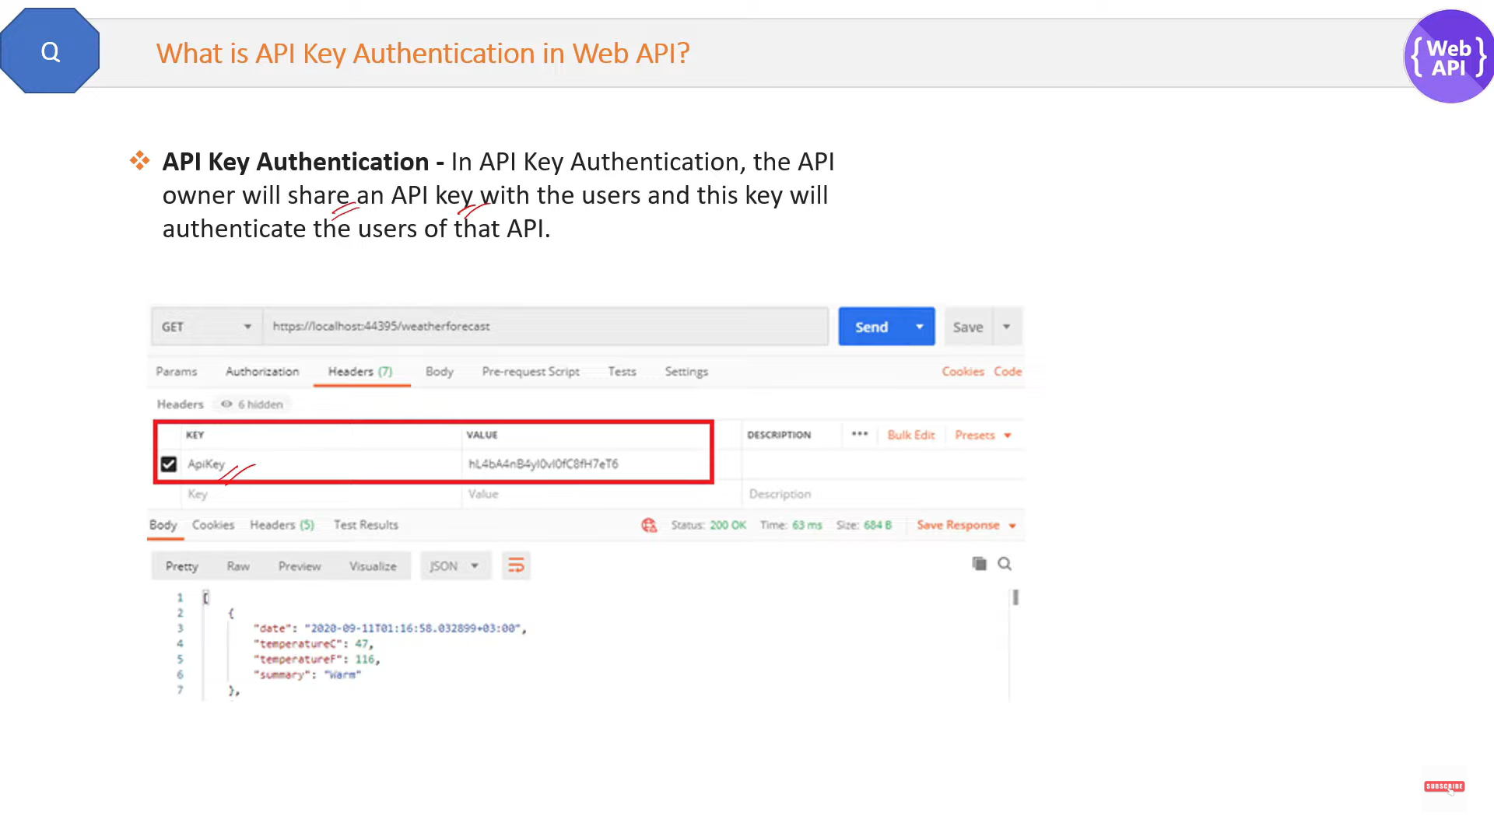 Token Based Authentication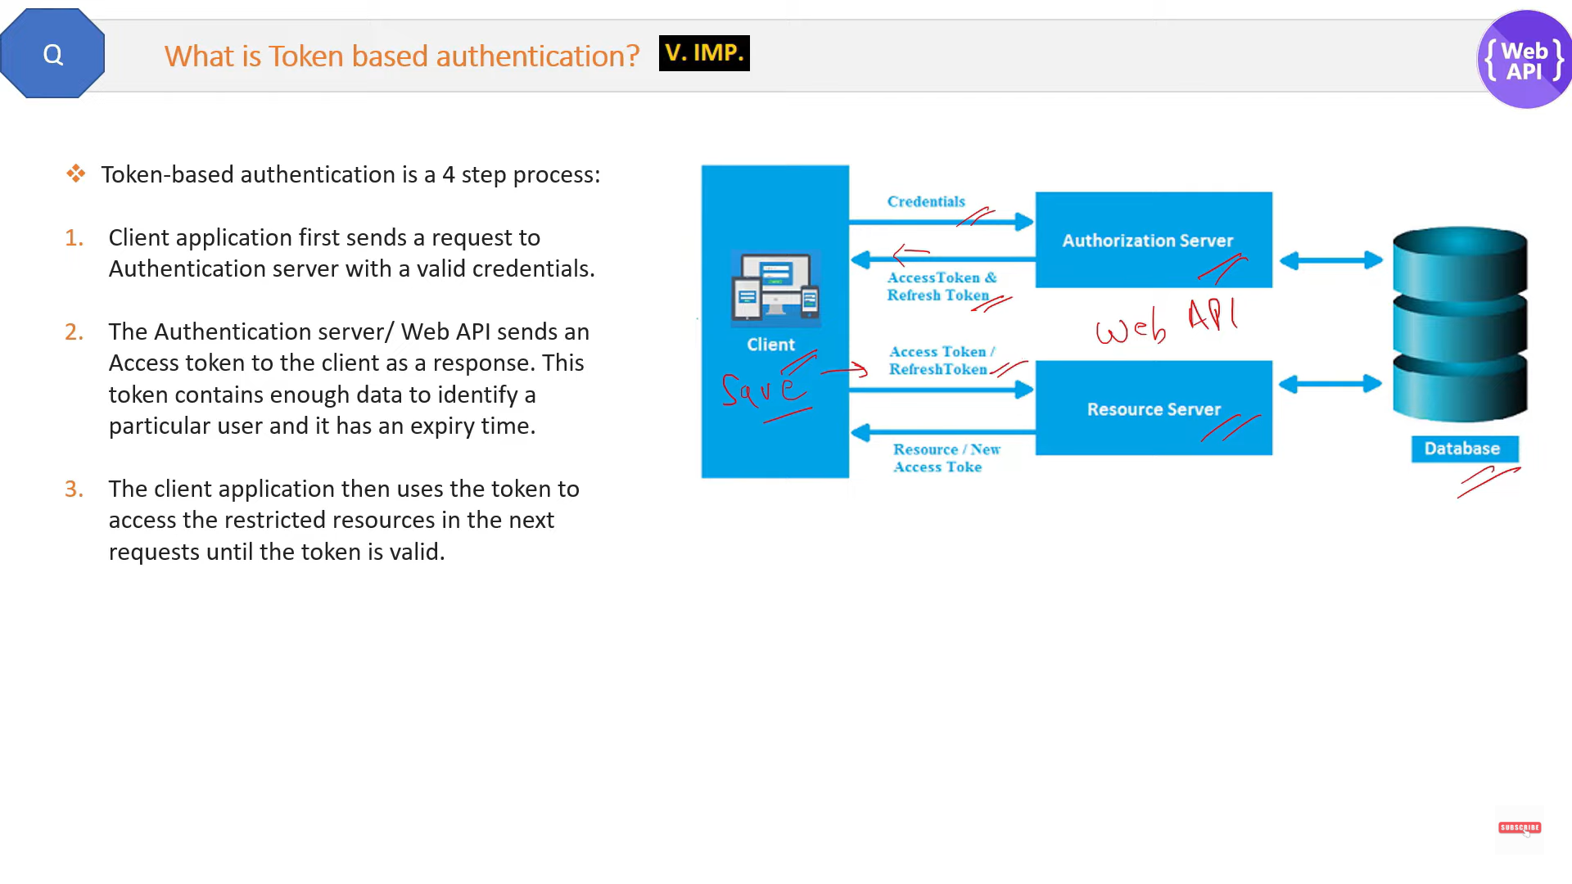

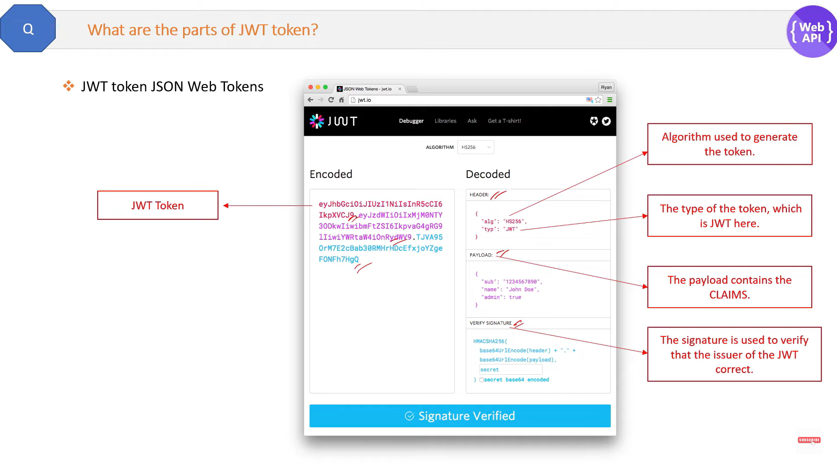

What is Rest and Restful web services

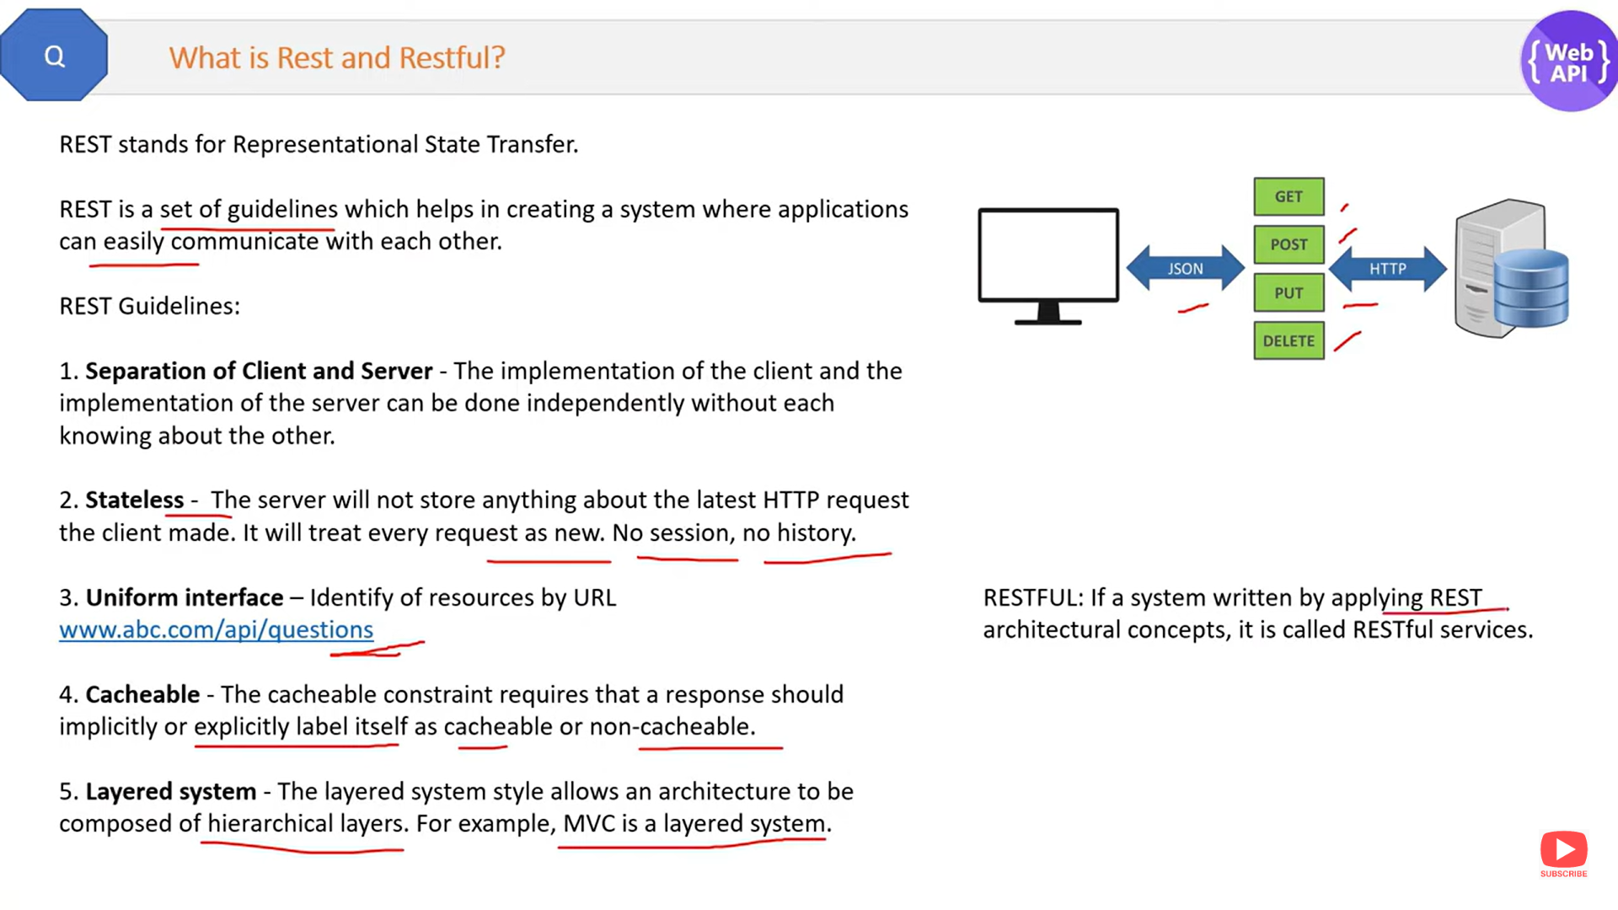

Http verb and http method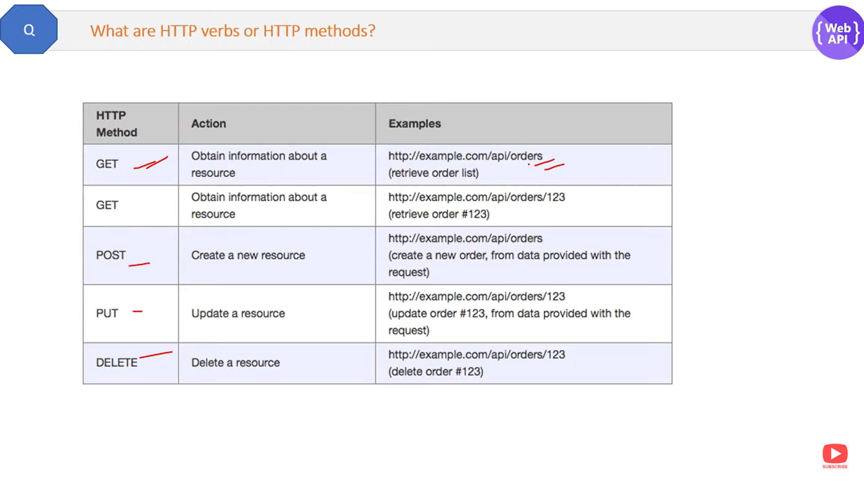

Return type web api

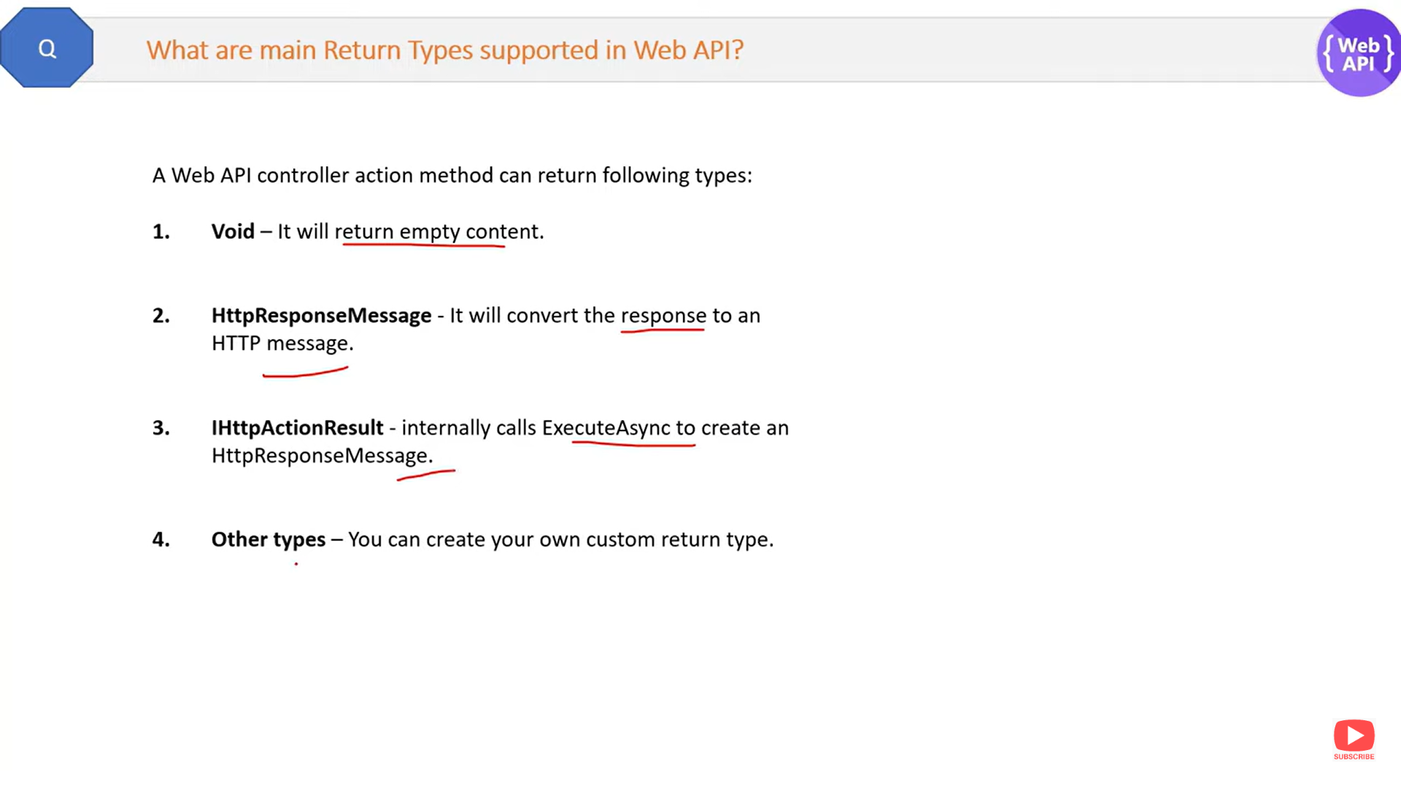

Enabling CORS for a REST API resource

[Cross-origin resource sharing (CORS)](https://developer.mozilla.org/en-US/docs/Web/HTTP/CORS) is a browser security feature that restricts cross-origin HTTP requests that are initiated from scripts running in the browser. If your REST API's resources receive non-simple cross-origin HTTP requests, we need to enable CORS support.

* Access-Control-Allow-Methods
* Access-Control-Allow-Headers
* Access-Control-Allow-Origin
* headers: {
* "Access-Control-Allow-Headers" : "*Content-Type*",
* "Access-Control-Allow-Origin": "*https://www.example.com*",
* "Access-Control-Allow-Methods": "*OPTIONS,POST,GET*"
* },